Geophysical Research Letters
Supporting Information for
Role of geostrophic currents in future changes of coastal upwelling in the California Currents System

Hui Ding^{1,2*}, Michael A. Alexander², and Michael G. Jacox³

1. CIRES, University of Colorado, Boulder, Colorado
2. NOAA Earth Systems Research Laboratory, Boulder, Colorado
3. NOAA Southwest Fisheries Science Center, Monterey, California

Contents of this file

Figures S1 to S5

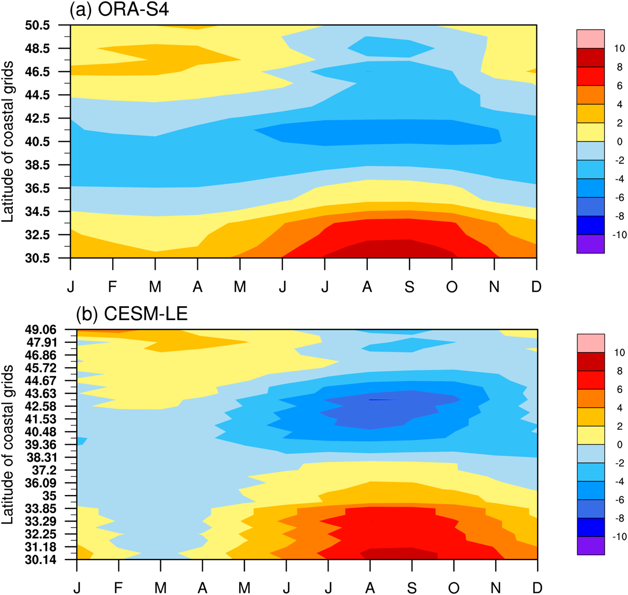

Figure S1. Sea surface height monthly climatological state from the first offshore grid, calculated from (a) ECMWF Ocean Reanalysis System 4 (ORA-S4; Balmaseda et al., 2013) and (b) CESM-LE. Mean values over the coastal grid cells have been removed from each grid cell to highlight alongshore sea level gradient. Abscissa indicates calendar month; tick marks on ordinate indicate actual latitude of grid cells. Data during 1958-2017 are used to calculate the climatological state. Unit is cm.

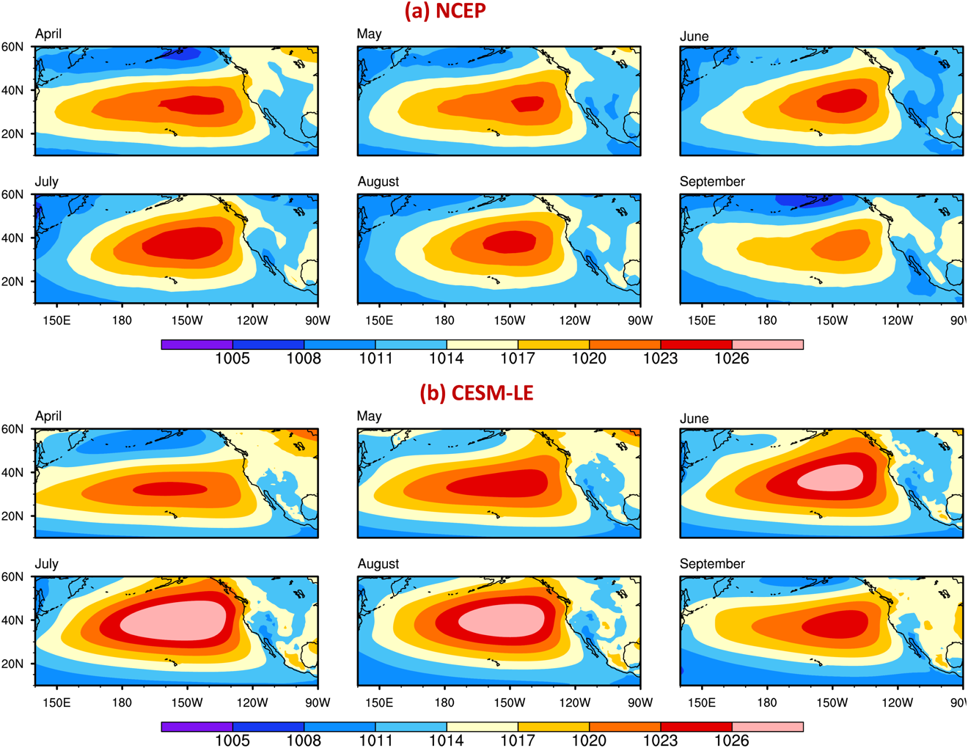

Figure S2. Sea level pressure monthly climatological state for April-September, calculated from (a) National Centers for Environmental Prediction reanalysis (NCEP; Kalnay et al., 1996) and (b) CESM-LE. Data during 1958-2017 are used to calculate the climatological state. Unit is hPa.

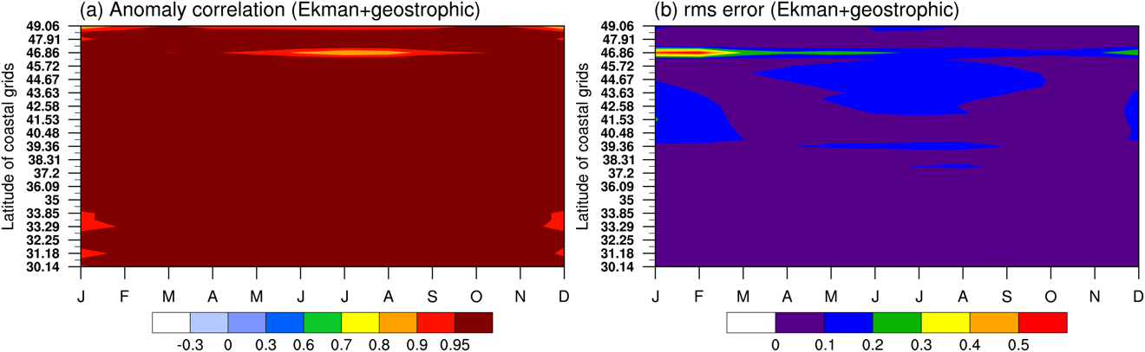
Figure S3. (a) Anomaly correlation (after removing monthly climatology) and (b) full-field room-mean-square error between vertical transport at 30m depth and the combination of Ekman and geostrophic components of the vertical transport. Data during 1920-2100 are used.

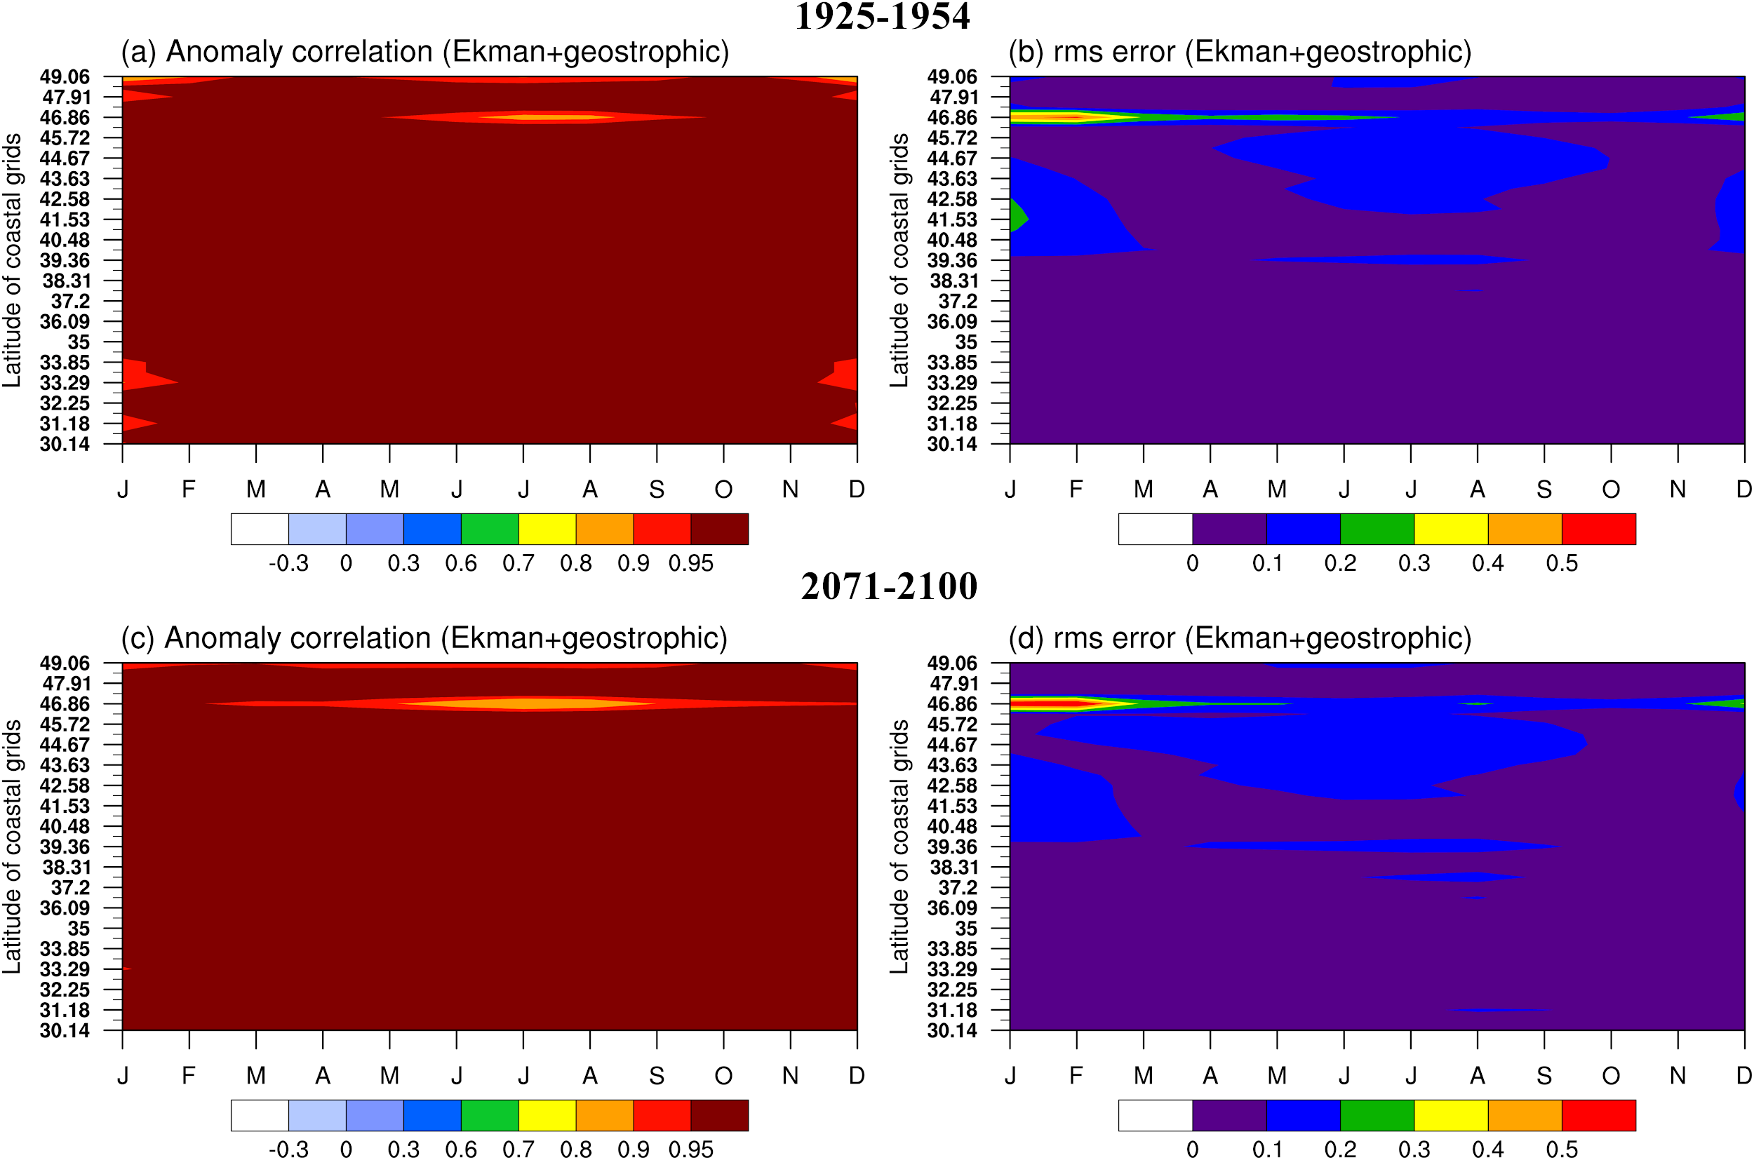
Figure S4. The same as Fig. S3 except for using data during (a, b) 1925-1954 and (c, d) 2071-2100, respectively.

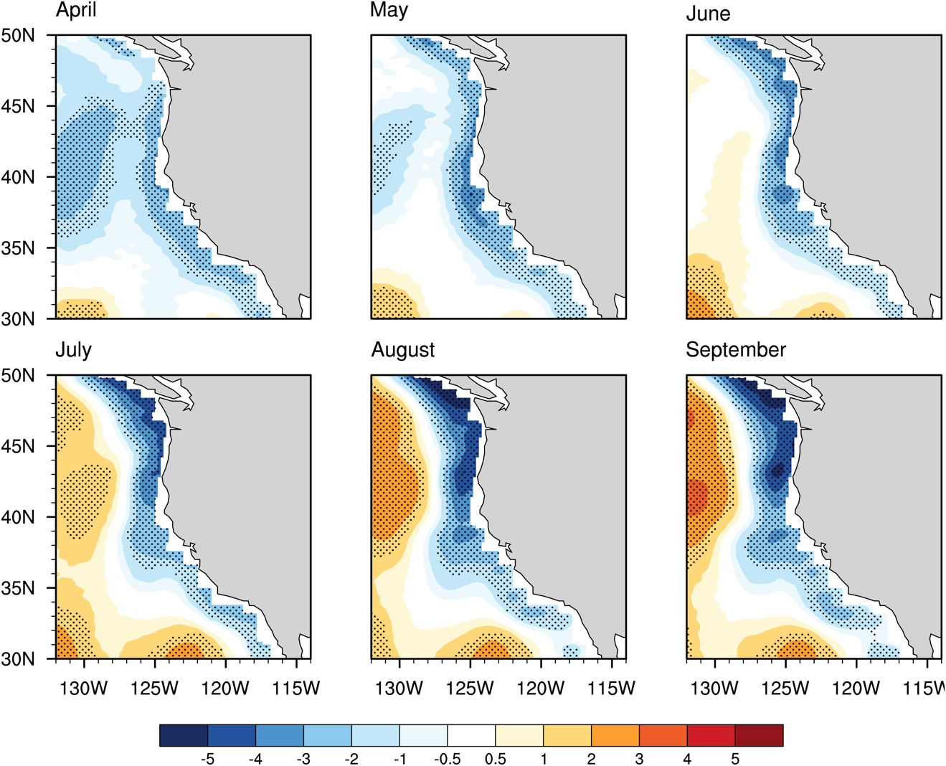

Figure S5. Monthly epoch difference (2071-2100 minus 1925-1954) for sea surface height for April-September near the United States west coast. Dots indicate 95% significance. Unit is cm.

